Project 1

*www.publicartwalkingtours.ie*

This website informs visitors about the selection of Tours on offer from the Public | Art | Walking | Tours Company. The site uses the AngularJS framework with routing and contains two API services (OpenWeather API and Google Maps API) which are used on the site through two directives. It was built using the bootstrap grid layout and is a responsive site that sizes appropriately on phone, tablet or PC. HTML5, CSS, JavaScript and jQuery are also used, along with a PHP script to send an email to the company from the User Form. It is hosted live on the address above and also on a development site at www.databasis.ie/PAWT.

Maria Hynes

April 2016

https://github.com/mariahynes/PAWT

Contents

1) THE BRIEF 2

2) MEETING THE BRIEF 3

2.1 Use of Images 3

2.2 Site Navigation 4

2.3 From Lists to Panels 5

2.4 User Experience 7

2.4.1 Information 7

2.4.2 Maps 8

2.4.3 Weather 9

2.4.4 Contact Form 10

3) TESTING 12

3.1 When testing on mobile phone 12

3.2 Using one map directive 12

3.3 Making a user form 12

3.4 The email should be validated 12

3.5 The user has to re-fill in all fields 13

3.6 Panel alignment was incorrect 13

4) FILE STRUCTURE 14

5) CODE REFERENCES 15

# THE BRIEF

The Public Art Walking Tours Company organise walking tours in Stephen’s Green in Dublin every summer from June to the end of September. They had an existing presence on the web, but needed a complete upgrade because of two events happening in 2016. They wanted to highlight that they were:

* introducing a new Tour of Merrion Square
* running additional tours in April as part of the One City One Book Festival

For reference please visit a copy of the previous site at <http://www.databasis.ie/publicartwalkingtours>. This site had been used for almost 5 years and they wanted their new site to look and feel very different whilst retaining the same familiar page headings. I was able to use content from the original site, therefore, as the starting point for the development of the new site. Please note that some content on the site will differ from the screenshots below because the live site has been updated since it was developed for this project.

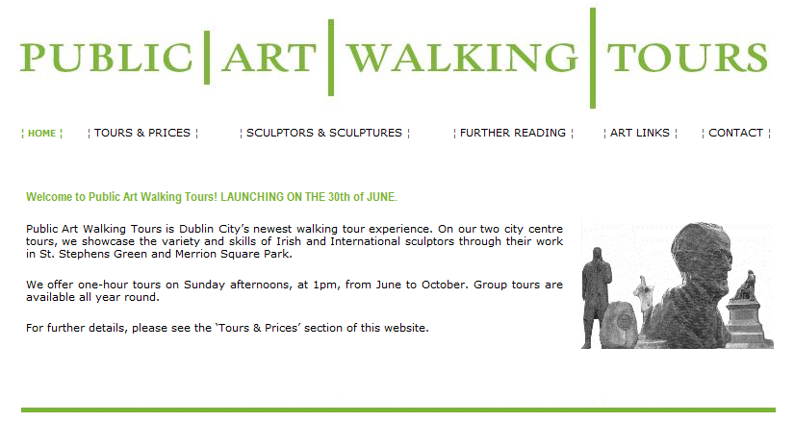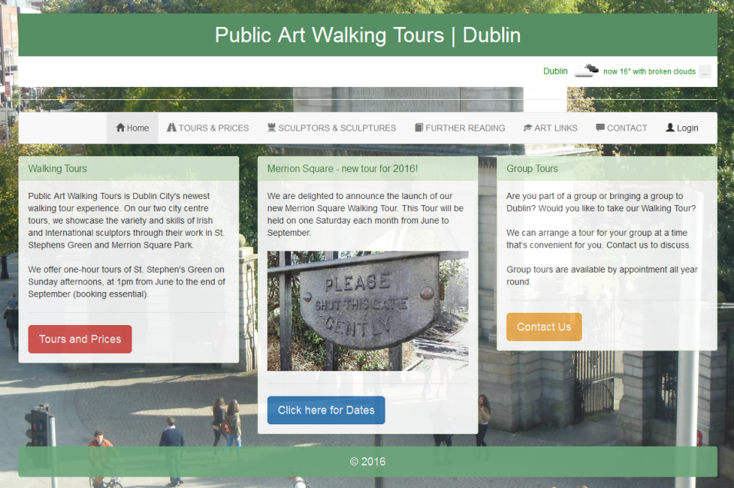

OLD

NEW

# MEETING THE BRIEF

### 2.1 Use of Images

In order to make the site look and feel different to the original site, the new site uses photographs of St. Stephen’s Green that change, using media queries[1], depending on screen size. At its smallest screen size, the background image is a vertical image of a narrow sculpture, whereas on tablet or PC the image is a horizontal view of the entrance to the park. The old site did not use images in this way, having only a white background on all pages.

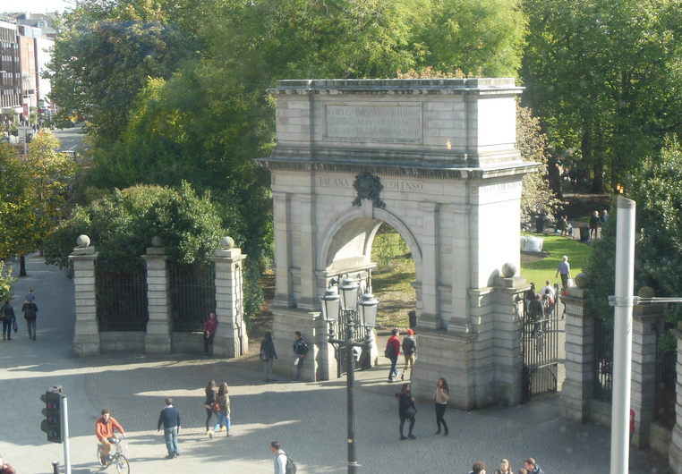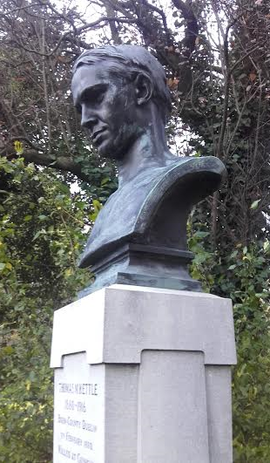

### 2.2 Site Navigation

The site is grouped under the same pages, but I introduced some bootstrap gyphicons to give a nice addition to the menu bar.



OLD

NEW



Using a responsive layout also means that on a small screen, the menu bar collapses to show the site name along with the ‘Menu’ icon. On clicking the ‘Menu’ icon, the items appear in a drop-down list.

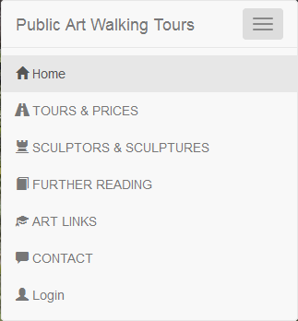

### 2.3 From Lists to Panels

Much of the original site used lists to display information. For the new site, I laid the information out in Bootstrap Panels to give an improved user-experience, organising the data into clear sections. Where possible I used images in the panels (see next page) to make the content more engaging.

OLD

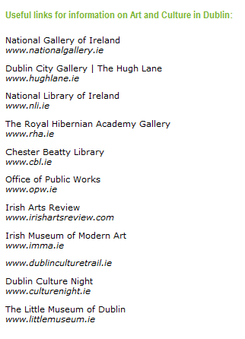

NEW

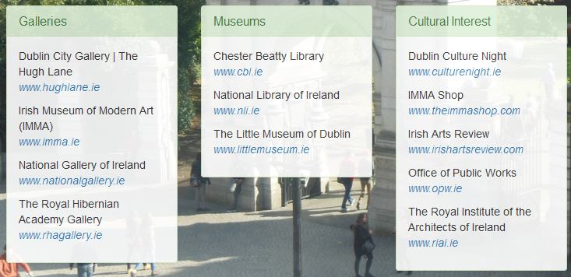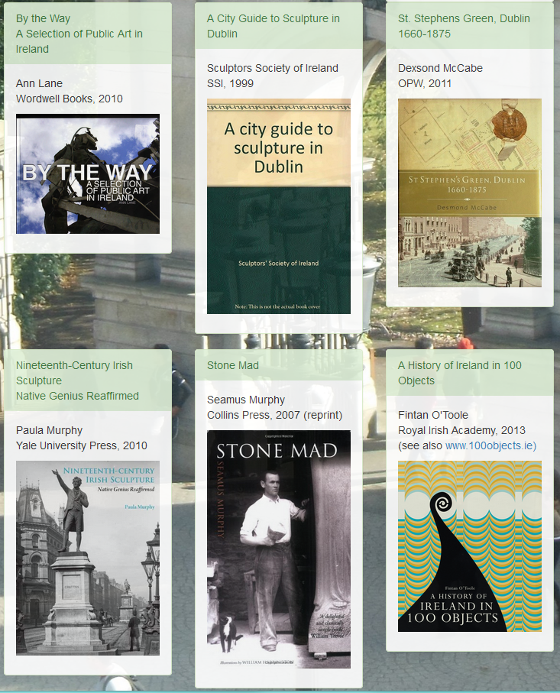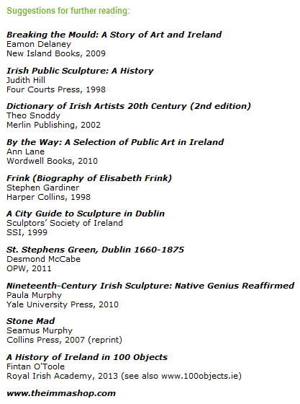

OLD

NEW

### 2.4 User Experience

### 2.4.1 Information

The original site only mentioned the times and dates of the Tour on the Home Page. In the new site, I decided to repeat this information on the Tours and Prices page and formatted it using Bootstrap Tables. This makes the information clear and concise and is a much more effective way to organise the data. Now the user can find all relevant information on the same page.

OLD

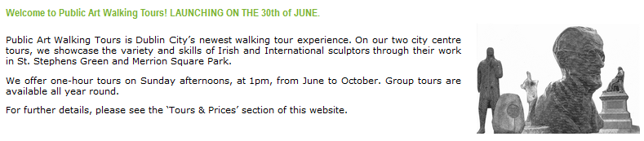

NEW

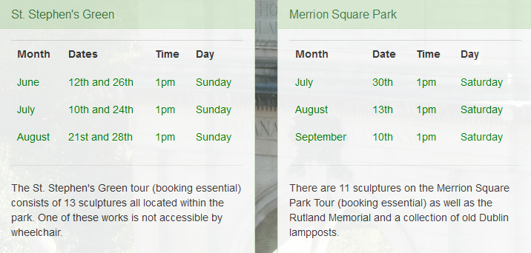

### 2.4.2 Maps

New visitors to Dublin would be considered the most typical profile of user to the website. Visitors to the city may not be familiar with the streets or the landmarks and so as not to lose a potential customer, I wanted to make it as easy as possible for someone to attend a tour. With this in mind I enhanced the meeting-point section using Google Maps to show, with one click, where *exactly* to meet on the first point on each of the Tours. Clicking on [Show me] reveals a map, hidden until needed. Using a transition affect, this map slides down and back up as needed. A user can also easily zoom in and out using the +/- map controls[2].

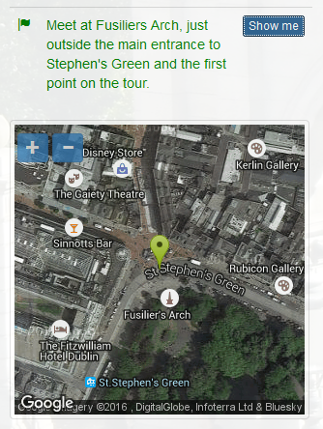

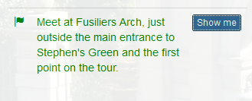

### 2.4.3 Weather

A handy feature for anyone planning an outdoor weekend event is to be to be able to easily check the weather forecast. On the header of each site page, I included a weather service using the OpenWeather API[3] <https://openweathermap.org/api>. This provides the user with the current weather at the time the site is accessed and on clicking a small icon it also provides a 5-day forecast. These are programmed as two separate Directives[4].

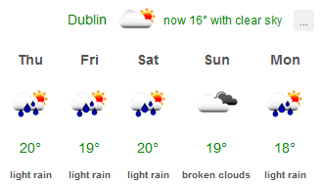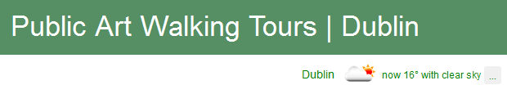

### 2.4.4 Contact Form

On the previous site, there was no form available for contacting the company. The contact details were listed on the Contacts Page, but there was no quick way to send feedback or seek information without leaving the site. In the new Contacts Page now the user can view the contact details as before (formatted in a clearer Bootstrap table) *or* the have the option of using the new feedback form.

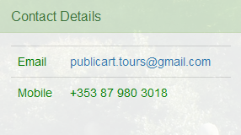

OLD

NEW

The new feedback form includes validation to ensure no fields are left blank and that the user’s email address is correctly entered twice. The field requesting a re-entering of the email address is purposely hidden until the user types into the existing email address field[5]. This is so that the user is guided *during* the process when they have already committed to using the form, rather than seeing, at the beginning, too many fields to fill in and possibly being discouraged from using the form.

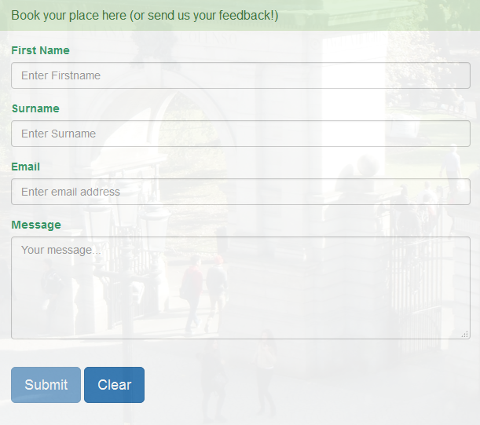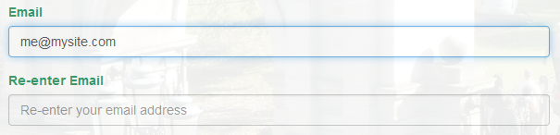

The site was deployed on 24th of March so that it would be live in time for the One City One Book Festival in April. The very next day the site had their first booking via this online form!

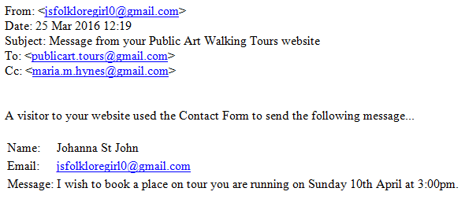

# TESTING

I tested this on Firefox, Chrome and Internet Explorer browsers, on a Samsung Tablet, an iPhone and multiple Android phones (Sony/Samsung). The following are a selection of the issues and the solutions I implemented.

* 1. When testing on mobile phone screen the list items on the Menu remained visible on screen even when a menu item was selected. This meant that although the new page content was loaded, the user had no indication that it had loaded and couldn’t see any difference until scrolling down. This was because the menu, on a small screen, takes up most of the screen when it is open. I needed to make the Menu list collapse when the user selected an item.

**Solution:** I added a script to remove the ‘in’ class from the Nav bar when any link is clicked on the Nav bar[6]

* 1. Using one map directive on a page worked perfectly (showing the map on click) until I introduced a second map on the same page. Two maps were needed, one for each Tour. With the code used, clicking to view one of the maps meant that both maps updated because they shared the same id tag.

**Solution:** While there were many ways to fix this, I chose to solve it by using the transitional affect that when the user clicks the button to open one map, the other map slowly closes. In the background they still both show the same map, but the user only sees one map at a time[7].

* 1. Making a user form that sent an email on Submit. I needed the form to be able to send an email to the Company.

**Solution**: I used a php script that sends an email to the site admin and I included my own email in the bcc field so that I could monitor the traffic[8]. Every tour that was scheduled for the One City One Book tour in April had bookings through this form.

* 1. The email should be validated and not sent until the required information is entered on the form.

**Solution**: I used AngularJS to provide the validation. It checks to see that there is a message typed in the message-box, that the user email addresses are repeated exactly the same, and that the user has entered a first name and a surname. The Submit button is not activated until all these conditions are met[9].

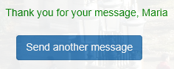3.5 The user has to re-fill in all fields, if they want to send a second message.

**Solution**: On submit of the form the user sees a thank you message with their first name. I included a button with the label, ‘Send another message’. If the user clicks this button **all** previous details that they entered (first name, surname and email) are pre-populated. They then only have to enter a new message.

3.6 Panel alignment was incorrect on the ‘Further Reading’ page on smaller screen sizes, with the use of image panels.

**Solution**: I used media query and a **repeat** class on each div on the page[10]. As a result on all media sizes the top of the panels align in each row:

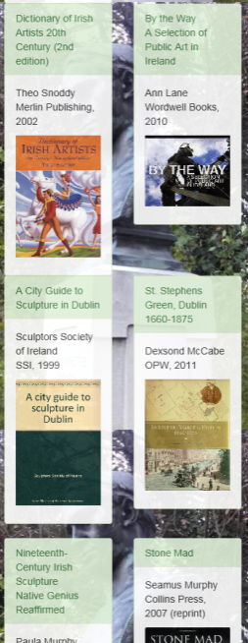

Phone Screen

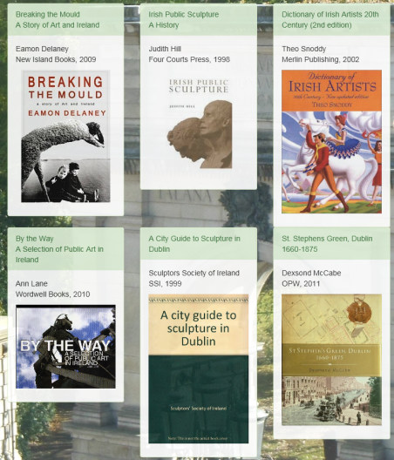

Tablet Screen

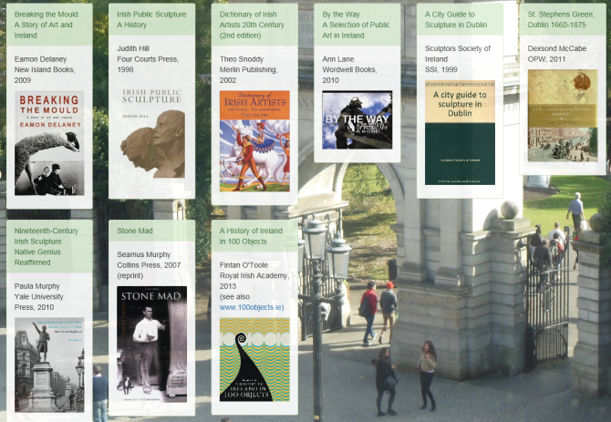

Large PC Screen

# FILE STRUCTURE

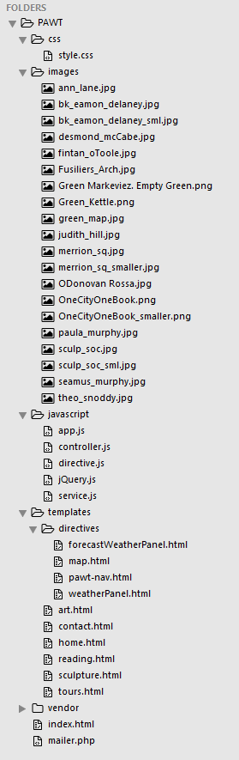



# CODE REFERENCES

[“You can easily change the formatting from the Quick Styles gallery on the Write tab.”]

1. Section of code from *style.css* showing use of media queries for body background images:

   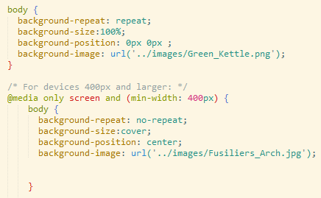
2. Section of code from *controller.js* and *directive.j*s to show the maps in action:

   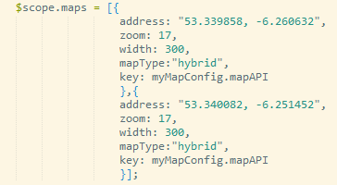

   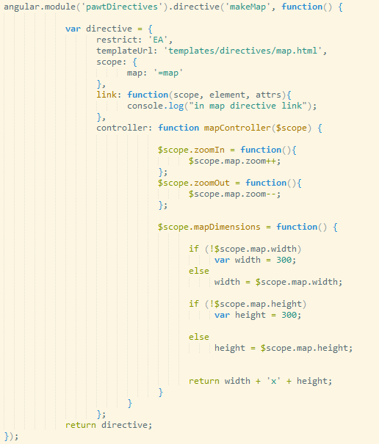
3. Weather API from *app.js*:

   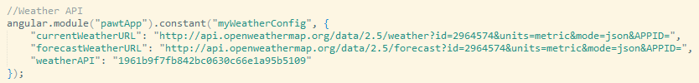
4. Section of code from *directive.js* and *forecastWeatherPanel.html* to demonstrate use of directive:

   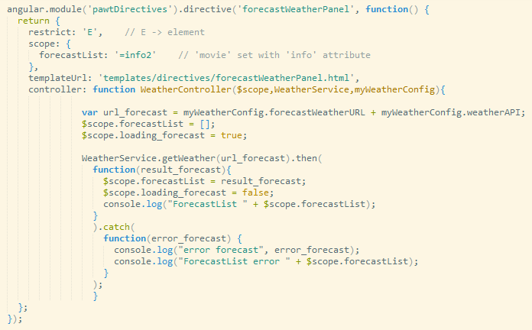

   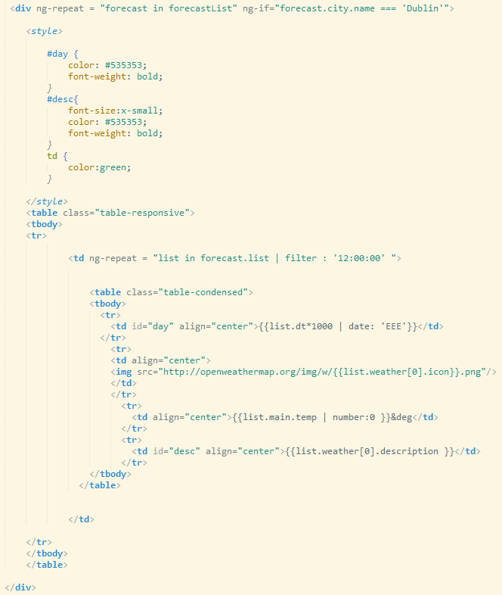
5. Section of code from *contact.html* showing how ‘email2’ field is hidden until ‘email’ field is valid:

   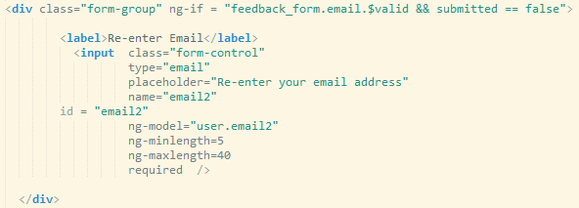
6. Section of code from *index.html* to collapse menu list on smaller screens:

   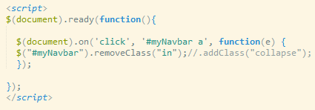
7. Section of code from *tours.html* showing map transition:

   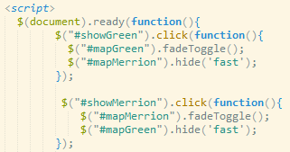
8. PHP mail script (*mailer.php*):

   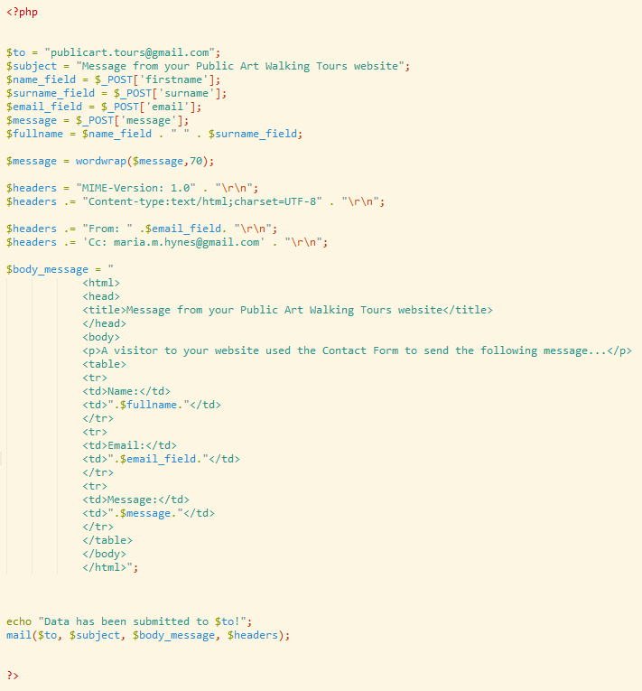
9. Section of code from *controller.js* showing form validation:

   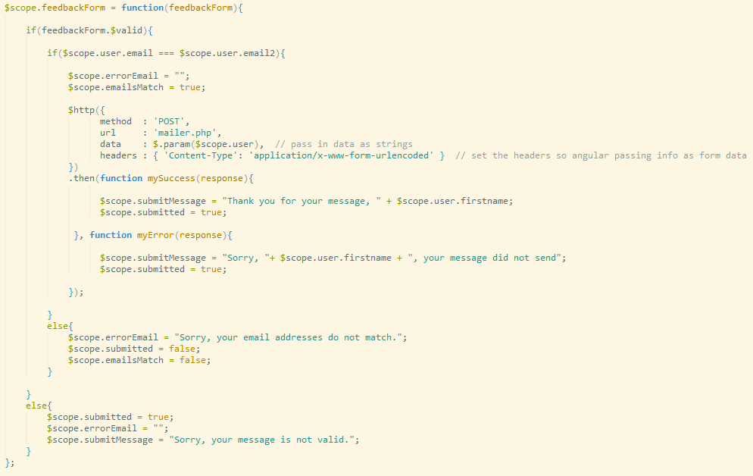
10. Section of code from *style.css* and *reading.html* to align panels:

    